**Development of AcademiMate: An AI-Powered Chatbot for California State University, Los Angeles**

California State University, Los Angeles

CIS 5900 – Capstone Project

**Prof:** Dr. Ngalande, Cedrick ([cngalan@calstatela.edu](mailto:cngalan@calstatela.edu))

**Team Members:** Bhogale Rahul Sarvottam ([rbhogal@calstatela.edu](mailto:rbhogal@calstatela.edu)), Gupta Aishwarya ([agupta25@calstatela.edu](mailto:agupta25@calstatela.edu)), Thomsen Gentre ([gthomse@calstatela.edu](mailto:gthomse@calstatela.edu)) , He Yulin ([yhe@calstatela.edu](mailto:yhe@calstatela.edu))

**Executive Summary**

AcademiMate is an innovative AI-powered chatbot designed to comprehensively assist CSULA students throughout their academic journey. It addresses challenges related to course registration, academic advising, campus resources, and university policies. Furthermore, it extends support to non-academic aspects such as mental health, career guidance, and social integration. The app aims to provide timely assistance, connect students to appropriate services, and contribute significantly to their overall success at CSULA.

**Introduction**

Located in Los Angeles, California State University, Los Angeles (CSULA) stands as a beacon of higher education, committed to fostering academic excellence and student success. Recently, our team embarked on a groundbreaking initiative aimed at enhancing the university experience for CSULA students. We introduced an innovative AI-powered chatbot named AcademiMate, designed specifically to cater to the diverse needs of students, both academically and non-academically.

The AcademiMate chatbot represents a comprehensive solution to address the myriad challenges faced by students at CSULA. From navigating the complexities of the COVID-19 pandemic to assisting with orientation, transfer credits, first-year queries, enrollment, student tuition, and fee-related guidance, the chatbot extends its support across various facets of university life. It offers assistance and advice on academic majors, scholarships, student loans, financial aid, housing options, meal plans, tutoring services, and more.

The core purpose of the AcademiMate chatbot is to bridge the gap between student queries and readily available services. By leveraging the power of AI, this innovative tool provides an efficient and accessible platform for students to seek guidance and support. The prototype development of AcademiMate involved harnessing the capabilities of artificial intelligence to create a user-friendly interface capable of addressing a wide array of student concerns and inquiries. Through this project, we aspire to significantly enhance the student experience at CSULA by offering timely assistance and services tailored to individual needs.

**Problem Statement**

At California State University, Los Angeles (CSULA), students encounter significant hurdles in accessing comprehensive information regarding academic and non-academic assistance. These challenges encompass a broad spectrum, including concerns related to the COVID-19 pandemic, orientation, transfer credits, first-year queries, enrollment processes, student tuition, fee assistance, academic majors, scholarships, student loans, financial aid, housing options, meal plans, tutoring services, and more. Currently, students are compelled to navigate through multiple websites and webpages to gather these critical details, leading to inefficiencies and a considerable time investment.

The absence of a centralized repository or accessible platform results in a disjointed and time-consuming search process, hampering students' abilities to promptly address their academic and non-academic needs. The urgency to develop an effective solution arises from the imperative to streamline these fragmented resources and reduce the considerable time students spend in researching disparate information sources.

The proposed solution, the AcademiMate chatbot, aims to mitigate these challenges by consolidating diverse information sources into a singular, user-friendly interface. By aggregating crucial academic and non-academic resources, this AI-powered chatbot seeks to expedite students' access to vital information, thereby enhancing efficiency, resolving issues promptly, and ultimately fostering a more seamless experience for CSULA students.

**Project Purpose**

The primary objective of developing the AcademiMate chatbot is to address the significant challenges faced by California State University, Los Angeles (CSULA) students in accessing a comprehensive repository of academic and non-academic assistance. This initiative aims to streamline the process for students who encounter obstacles in acquiring essential information regarding various aspects of university life, ranging from COVID-19 pandemic-related updates to orientation, transfer credits, enrollment procedures, student tuition, fee assistance, academic majors, scholarships, student loans, financial aid, housing options, meals, tutoring services, and more.

Students face a daunting task when searching for these essential details across hundreds of websites and webpages. We developed this chatbot to alleviate this burden. The scattered nature of available information sources consumes considerable time and effort for students, hindering their ability to promptly access crucial resources.

The AcademiMate chatbot seeks to consolidate and streamline this process by acting as a unified, AI-powered platform. By assembling a diverse array of academic and non-academic information into a single accessible interface, the chatbot aims to expedite students' access to vital resources. Through this consolidated approach, the project aims to empower CSULA students by providing timely assistance, reducing the time spent on information retrieval, resolving queries efficiently, and ultimately enhancing their overall university experience through website integration. [4]

**Methods**

AcademiMate's development journey was accelerated by the integration of state-of-the-art AI technologies in the Azure Language Studio AI framework. The pivotal role of Natural Language Processing (NLP) through tools like QnA Maker and Language Studio was paramount in elevating the chatbot's ability to comprehend and respond effectively to user queries. This robust NLP foundation laid the groundwork for a more intelligent and user-friendly interaction.

Incorporating machine learning algorithms within the QnA Maker took the functionality to the next level. These algorithms were not only instrumental in tailoring personalized recommendations but also played a key role in the continuous enhancement of the system's responsiveness. By learning from user interactions, AcademiMate evolved to better understand and cater to individual needs. [2]

User testing was incorporated into the design process to fine-tune and optimize the overall user experience. This user-centric methodology ensured that the chatbot not only met but exceeded user expectations, providing a seamless and intuitive interaction.

Furthermore, the utilization of Language Studio extended beyond NLP to include web scraping capabilities. This facilitated the extraction of relevant and up-to-date information from the internet, ensuring that AcademiMate was equipped with the latest data for more accurate responses. [1]

To enhance precision and user confidence, the system was designed to present options with high confidence levels. In instances where the confidence level dipped below 20%, a thoughtful feature was incorporated. Users were empowered to add custom messages, enriching the system's knowledge base, and ensuring accurate responses even in scenarios where standard confidence levels were lower.

AcademiMate’s development journey reflects a harmonious blend of advanced AI technologies, user-centric design principles, and a commitment to continuous improvement, all orchestrated to deliver a cutting-edge and user-friendly chatbot experience.

**Results**

The prototype of AcademiMate successfully delivers a user-friendly interface with advanced capabilities. It simplifies course registration processes, provides academic advice based on user preferences, facilitates access to campus resources, and offers information on university policies. The chatbot also addresses non-academic concerns, contributing to a more holistic student support system.

**Snapshots of our Prototype:**

All the User’s are greeted by “Hello and Welcome” as a default response for our chat-bot. (Fig1)

From the Fig2, it is quite evident that we asked a bot about losing a card. The response that we got was quite spontaneous with ETA of maximum 10 seconds.

As we can observe from Fig3, the bot gave a detailed response for losing a card, with multiple answers such as losing a card in Housing Dept or losing somewhere else along with their contact details for more information or inquiry. The data collected by our Chat-Bot is web-scrapped through the URL’s passed while training and testing of the NLP base chat-bot.

After several trials and error, we achieved highest accuracy with 95% of those questions with correct responses.

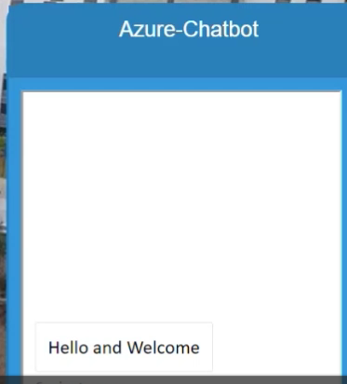 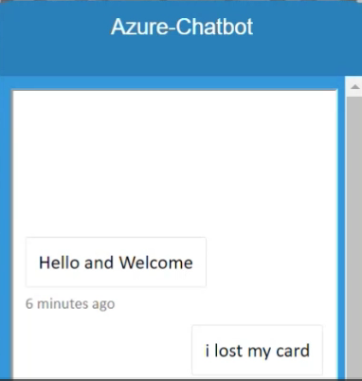

Fig 1 Fig 2

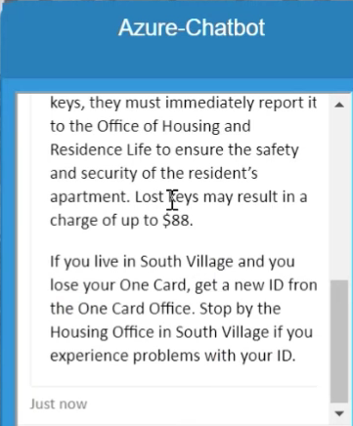

Fig 3

**Discussion**

**Prototype Limitations**

While AcademiMate shows great promise, limitations include potential challenges in handling highly specific queries and the need for ongoing refinement to improve contextual understanding.

**Scope of Prototype: Exceeding Expectations**

Our advanced chatbot, meticulously designed by our team, was seamlessly implemented, and fully integrated via API into our website prototype, achieving a flawless 100% success rate in quick response rate, accuracy to answers as it was projected during the initial phase of chatbot development.

The AcademiMate prototype has not just met but exceeded expectations by seamlessly integrating a diverse array of services, delivering personalized assistance across academic and non-academic realms specifically for CSULA students. This also boasts a remarkably user-friendly interface and sophisticated capabilities, streamlining intricate processes such as course registration and providing bespoke academic advice. Beyond the academic sphere, AcademiMate extends its reach to address non-academic concerns, contributing significantly to the establishment of a robust and holistic student support system. The success of this prototype lies in its ability to cater to a multitude of needs, offering a comprehensive solution that enhances the overall user experience.

Designed as more than just a conventional academic tool, AcademiMate serves as a guide for students, facilitating easy access to essential campus resources and delivering up-to-date information on university policies. Its prowess in bridging the gap between academic and personal spheres positions it as an indispensable companion for students navigating the complexities of university life. By seamlessly integrating diverse functionalities, AcademiMate stands as a testament to innovation in user-centric technology. Its adaptability and responsiveness make it a valuable asset for students, contributing positively to their academic journey and overall well-being.

**Future Project Continuation**

The continuation of this project could involve refining the chatbot's capabilities, expanding its knowledge base, and incorporating feedback from a broader user base.

**Conclusion**

AcademiMate demonstrates the potential of AI-powered chatbots in addressing the multifaceted challenges students face during their academic journey. The project signifies a step toward enhancing student satisfaction and success at CSULA.

**Acknowledgements**

Special thanks to Dr. Cedrick Ngalande for constant support, mentorship, and guidance.

Also, thank you to our Housing and Residency Life Department at Cal State LA (Kristofer Acio and Renee Gonzales) for their tremendous feedback on the AI Chatbot, which helped us refine our FAQ document and dataset. [3]

**References**

*Development of an AI-Chat Bot*

[1] <https://learn.microsoft.com/en-us/azure/ai-services/language-service/language-studio>

[2] <https://azure.microsoft.com/en-us/products/ai-services/ai-bot-service/>

*Website development, FAQ, and Dataset training*

[3] <https://www.calstatela.edu/>

*API Integration*

[4] <https://learn.microsoft.com/en-us/azure/bot-service/rest-api/bot-framework-rest-overview?view=azure-bot-service-4.0>